THIS PAGE IS FOR YOUR REFERENCE ONLY. DO NOT SUBMIT THIS PAGE WITH THE REST OF YOUR GRANT.

RECRUITMENT AND RETENTION PLAN (RRP)

OVERVIEW AND ORGANIZATION OF THE PLAN
Effective participant recruitment is vital to the success of clinical trials. A detailed recruitment and retention plan for the coordinating center will help ensure sites have a well-qualified recruitment team, specific strategies for recruitment and retention, and an adequate budget and resources to implement the work. This document is intended to enhance participant recruitment and maximize retention. Formatting of this document follows NIH guidelines, as explained here.

The purpose of this Recruitment and Retention Plan (RRP) is to:
- To organize and describe recruitment feasibility and planned recruitment strategies for the study with an emphasis on stakeholder engagement, evaluation, and metrics to drive decision-making and resource allocation.
- To provide data-based projections and milestones for recruitment.
- To identify potential threats/risks to recruitment and proactively provide mitigation strategies.
- To establish a mechanism for providing the RIC with periodic updates on progress toward recruitment goals and success of recommended strategies.
- To serve as a guidance and training document for study sites.

The RRP is divided into the following sections:
- Study Overview
- Site Identification and Analysis
- Recruitment and Retention Timeline
- Recruitment and Retention Team
- Recruitment and Retention Methods
- Barriers and Proposed Solutions
- Stakeholder Identification and Communication Plan
- Evaluation
- Budget

THIS PAGE IS FOR YOUR REFERENCE ONLY. DO NOT SUBMIT THIS PAGE WITH THE REST OF YOUR GRANT.
Requested Inputs:
☐ Study Logo (if you have one)
☐ Specific Aims
☐ Review of Literature (if performed)
Similar studies
Similar population
☐ List of Identified Sites
☐ List of any known competing studies
☐ Site feasibility surveys or data
☐ EHR Cohort Analysis Data (if performed)
☐ Lessons learned from previous, similar studies
☐ Enrollment Timeline
☐ Screening Log Template
☐ Description of Participant Flow
☐ Consent Documents
☐ Final or near final protocol
☐ Manual of Operations
☐ Corrective Action Plan
☐ Monitoring Plan
☐ List of Key Study Personnel
☐ Study Team Requirements (if not included in MOP)
☐ Planned Recruitment Materials (can be just a list of planned approaches)
☐ List of top Recruitment and Retention Concerns
☐ List of known collaborators (community groups, businesses, churches, professional organizations, disease-related organizations)
☐ Access to Community Advisory Board (if you have one)
☐ Community Advisory Board Recommendations (if you have one)

THIS PAGE IS FOR YOUR REFERENCE ONLY. DO NOT SUBMIT THIS PAGE WITH THE REST OF YOUR GRANT.

Recruitment and Retention Plan
STUDY TITLE

This page can be used to keep track of any updates to the RRP after it is finalized. The Version Control Log should be updated by the appropriate study team member as soon as changes are implemented to ensure quality control is maintained.

Version Control Log
Version | Date | Description of Changes | Date of Notification to Stakeholders

Definitions, Acronyms and Abbreviations
Term | Explanation

A. STUDY OVERVIEW
Purpose of the Study
Why is this study being done?

Description of the Study
Elevator speech

Value of Participation to the Study Participant
Why would anyone other than the PI want to do this? How is the study team going to “sell” this study?

Study Population
Describe the study population (age, gender, healthy/non-healthy, urban/rural, socioeconomic status, disability, any characteristics that may influence recruitment, enrollment, and retention.

Table X. Inclusion and Exclusion Criteria
Inclusion Criteria | Exclusion Criteria

Participant Flow
Describe the process of participant identification, screening, consenting, enrolling

Study Visits
Provide information on the breakdown of study visits, including the # of visits and study components completed at each visit (if possible).

Table X. Study Visit Breakdown
Study Component | Visit 1 | Visit 2 | Visit 3 | Visit 4
Component 1 | X
Component 2 |  | X | X | X
Component 3 | X |  |  | X

B. SITE IDENTIFICATION AND ANALYSIS
Site Feasibility
Describe how availability and accessibility were determined at each site.

Site Identification
Describe the site selection process.

Site Activation
Prioritize which sites will be open to enrollment first and how the experience of those sites will be utilized to provide a smoother implementation for other sites. Describe the timeline and process for site initiation including the number of sites that can be initiated at one time.

Table X. Study Site Assessment
Site Name | Availability | Accessibility | Enrollment Goal | Competing Studies?

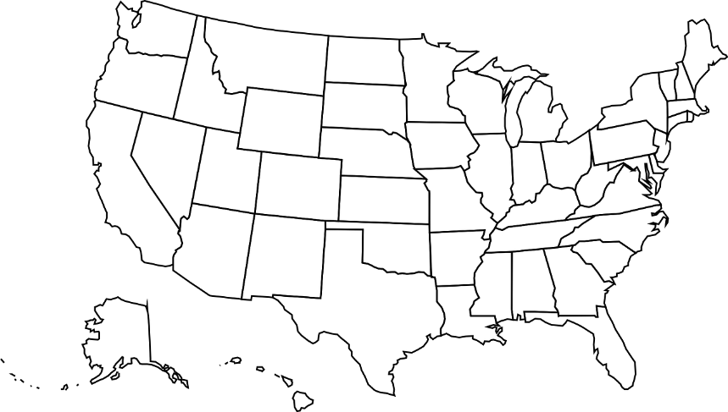

FIGURE X. Study site locations (marked as stars) across the US.

C. RECRUITMENT AND RETENTION TIMELINE

FIGURE X. Cumulative Quarterly Enrollment Projections

Enrollment for Underrepresented Racial and Ethnic Minorities
Describe how this will be addressed by the study team. Describe support available.

Monitoring of Screening and Enrollment
Describe who will be responsible for overall recruitment and retention across sites and how, to whom and with what frequency enrollment status will be reported at each site. Include any information on screening logs.

Corrective Action Plan
Describe the risk(s) of slow study start-up on enrollment and overall study timeline. Provide solutions for preventing risks and/or overcoming slow study start-up. Describe/define “trigger” points for intervention at a study site including who will be contacted for assistance with recruitment if enrollment falls below expected goals. What are the “trigger” points for early termination of a study site due to poor enrollment/attrition? What are the “trigger” points for early termination of the study due to poor enrollment/attrition?

D. RECRUITMENT AND RETENTION TEAM
Recruitment and Retention Team Training and Evaluation
Describe the coordinating center’s recruitment and retention team’s experience recruiting and retaining the study population. If no experience, describe how your team will acquire the necessary skills. Describe the coordinating center’s recruitment team’s experience recruiting and retaining underrepresented racial and ethnic minorities and other vulnerable populations. If no experience, describe how your team will acquire the necessary skills/cultural competencies. Describe how changes to study protocol including eligibility criteria or unexpected add-on training will be recommended, approved, recorded, and communicated to the recruitment and retention team. Include plans for communication across multiple sites if applicable. How will study-specific training be evaluated?

Study Team Turnover
Describe how turnover in recruitment and retention team personnel will be handled to minimize a delay in recruitment.

Table X. Recruitment and Retention Team Responsibilities
Team Member | Responsibility
 | Study Communication | (Pre) Screening | Consenting | Enrollment | Monitoring | Evaluating | Retention | Study Conduct | Return of Results

E. RECRUITMENT AND RETENTION METHODS
In collaboration with the RIC, we identified methods for recruitment and retention of individual participants, as well as methods to engage key study personnel at individual sites (Table X).

Participant Compensation
Describe any participant compensation. If no compensation, delete this section.

Delivery of Study Results to Participants
Describe how and when study results will be provided to participants. If included in the attached Communication and Implementation table, you can delete this section.

Monitoring of Attrition and Corrective Action Plan
Describe how, to whom and with what frequency participant attrition and missed visits will be reported at each site. Describe all efforts to reduce attrition and course correct if necessary.

Table X. Strategies for Awareness, Engagement, Recruitment, and Retention.
AWARENESS and SITE ENGAGEMENT |  |  | AUDIENCE |  |  |  |  |  |  | EVALUATION AND METRICS
 |  |  | Leadership | Study Staff | Sites | Departments | Health Care Providers | Patients | Advocates and Community Partners
Strategy | Description | Priority
SCREENING |  |  | AUDIENCE |  |  |  |  |  |  | EVALUATION AND METRICS
 |  |  | Leadership | Study Staff | Sites | Departments | Health Care Providers | Patients | Advocates and Community Partners
Strategy | Description | Priority
CONSENT and ENROLLMENT |  |  | AUDIENCE |  |  |  |  |  |  | EVALUATION AND METRICS
 |  |  | Leadership | Study Staff | Sites | Departments | Health Care Providers | Patients | Advocates and Community Partners
Strategy | Description | Priority
RETENTION |  |  | AUDIENCE |  |  |  |  |  |  | EVALUATION AND METRICS
 |  |  | Leadership | Study Staff | Sites | Departments | Health Care Providers | Patients | Advocates and Community Partners
Strategy | Description | Priority
PARTICIPANT ENGAGEMENT AND SATISFACTION |  |  | AUDIENCE |  |  |  |  |  |  | EVALUATION AND METRICS
 |  |  | Leadership | Study Staff | Sites | Departments | Health Care Providers | Patients | Advocates and Community Partners
Strategy | Description | Priority

F. BARRIERS AND PROPOSED SOLUTIONS
Through our partnership with the Recruitment Innovation Center (RIC), a part of the Trial Innovation Network (TIN), we identified potential barriers, assessed their risk level, and developed mitigation strategies that are outlined below (Table X). The risk score assigned to each potential barrier was calculated as the sum of the probability that the risk would occur (with 1 being improbable and 5 being highly probable) and the impact the risk would have on the study should it occur (with 1 being low and 5 being high).

Table X. Potential Barriers and Mitigation Plans
Potential Barrier | Risk Score  (1=lowest, 10=highest) | Mitigation Plan | Person responsible for plan execution

G. STAKEHOLDER IDENTIFICATION AND COMMUNICATION PLAN
In collaboration with the RIC, we identified key stakeholders and then devised the Stakeholder Communication Plan (Table X). The priority score assigned to each stakeholder was calculated as the sum of the stakeholder’s interest in enrollment (with 1 being low interest and 3 being high interest) and the stakeholder’s influence over-enrollment (with 1 being low influence and 3 being high influence). This Stakeholder Communication plan will ensure that an appropriate level of communication is planned for each stakeholder during each study phase.

Table X. Stakeholder Analysis and Communication Plan
STAKEHOLDER | Priority  Score | Communication Plan
Leadership
STAKEHOLDER | Priority  Score | Communication Plan
Sites
STAKEHOLDER | Priority  Score | Communication Plan
Departments
STAKEHOLDER | Priority  Score | Communication Plan
Health Care Providers
STAKEHOLDER | Priority  Score | Communication Plan
Patients
STAKEHOLDER | Priority  Score | Communication Plan
Advocates and Community Partners

H. EVALUATION
Describe how and when the coordinating center will know what R&R methods are working and what methods are not the best utilization of resources. Describe how patient engagement and satisfaction will be assessed during the study. Describe how study participants who screen out or refuse consent will be encouraged to participate in future studies. If described elsewhere in this plan, then reference that section instead of repeating the information already provided.

FOR YOUR REFERENCE ONLY. DO NOT SUBMIT WITH THE REST OF YOUR APPLICATION.

I. BUDGET
Create a line item for each recruitment and retention method describe above, a brief description of the cost and an estimate of the cost. Encourage the study team to record the actual costs of each method for lessons learned.
TABLE VI. Recruitment and Retention Budget Considerations
Resource | Description | Allocation
Recruitment/Retention Team |  | $
Incentives |  | $
Recruitment Activities |  | $
Retention Activities |  | $
Training |  | $
Postage |  | $
Feasibility |  | $
Compensation |  | $
Phone |  | $
Reimbursements |  | $
Other |  | $
Other |  | $
Total: |  | $ 0

NOTE: Once a final plan has been accepted by the study team, the final plan will be adapted for a REDCap survey to be given to site’s to help them develop their site-specific plans.

